GIFTTHREAD SA
Custom Clothing & Personalized Gifts Platform
Full Project Proposal & Technical Specification
Version 1.0 | June 2026
Confidential – For Internal Use & Potential Partners
Figure 1: Homepage Concept Mockup
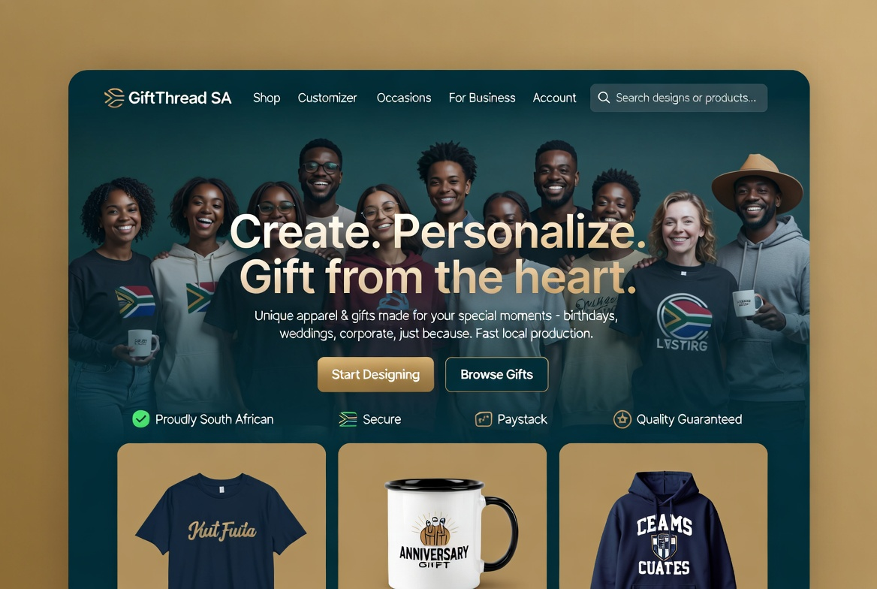

Prepared as a comprehensive blueprint for building a differentiated, locally-optimized custom apparel and gifting platform in South Africa.

Table of Contents

1. Executive Summary
GiftThread SA is a proposed full-stack web platform that empowers individuals, corporates, schools, and creators to design and order high-quality custom clothing and personalized gifts with a seamless, modern experience. The platform combines a powerful yet intuitive design customizer, strong gifting workflows, and a hybrid fulfillment model that leverages both global print-on-demand (POD) infrastructure and fast local South African production partners.
The South African market shows clear demand for personalized products — from birthday and anniversary gifts to corporate team wear, school events, weddings, and creator merch. Existing solutions either offer limited customization UX, rely heavily on slow/expensive international fulfillment, or lack integrated gifting features. GiftThread addresses these gaps directly.
Core Value Proposition: "Design in minutes. Gift with meaning. Produced locally where it matters, delivered fast."
This proposal outlines the full product vision, technical architecture (Django + Angular + Fabric.js customizer), phased development roadmap, operations strategy, business model, and immediate next steps. The project is designed for solo-founder execution with AI-assisted development, targeting an MVP launch within 8–10 weeks.

2. Market Opportunity & Problem Statement

2.1 The Opportunity
Personalization continues to be one of the strongest trends in consumer and gifting behaviour globally and in South Africa. Key drivers include:
- Growing middle class and event culture (weddings, birthdays, graduations, corporate functions)
- Rise of creator economy and demand for custom merch
- Corporate gifting and team-building wear post-pandemic
- Schools and universities seeking affordable, high-quality custom apparel and gifts
- Desire for faster, more reliable local production versus overseas POD (customs delays, high shipping, carbon footprint)

2.2 Current Market Gaps
Existing players in the SA custom apparel space (Teeprint, OneOff, Lucani, OTC Printing, and international platforms like Printful) offer good production quality but typically suffer from one or more of the following:
- Clunky or limited online customizers (poor preview quality, limited fonts/layers)
- Weak or absent dedicated gifting experience (no recipient messaging, occasion templates, beautiful unboxing)
- Heavy reliance on international fulfillment for broad product ranges, leading to long delivery times
- Limited integration between design tool, payments, and order tracking
- Little focus on POPIA-compliant handling of personal designs and customer data
GiftThread’s differentiation: A purpose-built, modern platform that combines best-in-class customization UX, thoughtful gifting flows, and intelligent hybrid fulfillment (global scale + local speed).

3. Proposed Solution & Product Vision
GiftThread is a responsive web application (PWA) that allows users to browse products, use a powerful live design customizer, save designs, and complete orders with integrated local/global fulfillment. The platform prioritizes speed, beauty, and emotional connection in the gifting process.

3.1 Target User Segments
- Individual Consumers: Personal gifts for family/friends (birthdays, anniversaries, “just because”
- Corporate & SMME: Team apparel, client gifts, event merchandise, staff onboarding
- Education & Institutions: School/university merch, graduation gifts, staff wear
- Creators & Artists: Merch drops, fan engagement (potential future marketplace)
- Event Planners & Weddings: Bridal party gifts, guest favours, signage

3.2 Core Product Pillars
- Beautiful Customizer: Fast, intuitive, professional-grade design tool (text, images, templates, layers, realistic previews)
- Gifting-First Experience: Occasion templates, recipient messaging, gift wrapping options, scheduled delivery notes
- Hybrid Fulfillment: Printful for breadth + fast local SA partners (OneOff Johannesburg, Teeprint, etc.) for speed and margin
- Trust & Compliance: POPIA-first data handling, secure design storage, transparent production tracking
- Mobile-First PWA: Excellent experience on phones and tablets for on-the-go gifting

4. Key Features & User Experience

4.1 Customizer (Core Differentiator)
The customizer is the heart of the product. It must feel premium and fast (under 90 seconds to create a nice design).
- Product selector with live colour and variant switching
- Canvas preview with realistic fabric texture and model/flat-lay views
- Text tool: multiple layers, system + uploaded fonts, curve/arc options, shadows/outlines
- Image upload with resize, rotate, position, basic filters, and optional background removal
- Template library organised by occasion (Birthday, Love, Corporate, Heritage, Family, Wedding, etc.)
- Layers panel, undo/redo, alignment tools, opacity, bring-to-front
- Save design to account (JSON + preview images) for later editing or reordering
- One-click “Add to Cart” with price breakdown (base + print sides + extras)

4.2 Gifting & Checkout Experience
- Dedicated “Create a Gift” flow with recipient name and personal message fields
- Gift wrapping and premium packaging options (upsell)
- Address book + multiple shipping addresses
- Paystack integration (cards, Instant EFT, other SA methods)
- Order tracking dashboard with production status from POD partner webhooks
- Post-purchase: reorder from saved designs, share design publicly (optional)

4.3 Admin & Operations
- Django admin + custom dashboards for orders, users, designs, and fulfillment status
- Content moderation queue for uploaded images/text (simple keyword + manual review)
- Bulk order / corporate quote request handling
- Analytics: popular designs, conversion funnel, top products, repeat purchase rate
Figure 2: Customizer Interface Concept
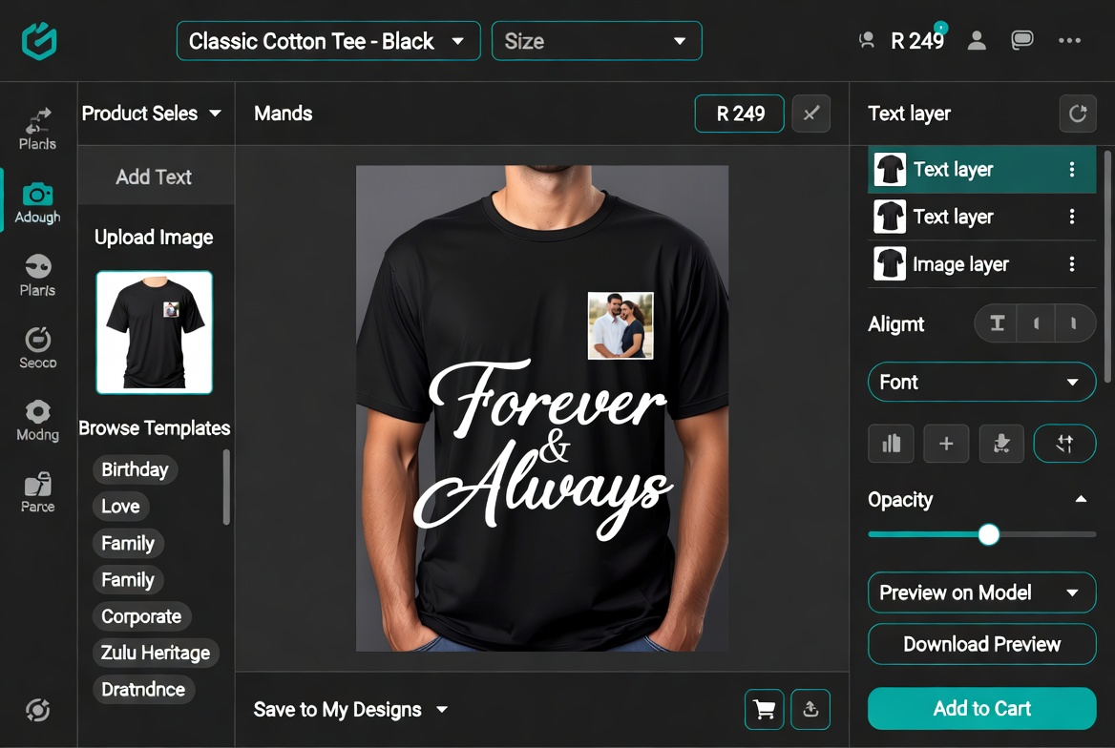

5. Technical Architecture & Recommended Stack
The architecture is chosen for rapid solo development, long-term maintainability, strong security/compliance posture, and alignment with proven patterns for complex custom e-commerce platforms.

5.1 Core Technology Stack
Layer | Technology & Rationale
Backend | Python 3.12 + Django 5 + Django REST Framework. Excellent admin, auth, ORM, security features, and rapid API development. Ideal for compliance-heavy applications.
Async / Tasks | Celery + Redis. Background jobs for image processing, order fulfillment submission, email/SMS notifications, and webhook handling.
Frontend | Angular 18+ (TypeScript) + Nx monorepo. Strong typing, component architecture, and excellent developer experience for complex UIs such as the customizer.
Design Editor | Fabric.js (canvas library). Industry-standard for print-on-demand customizers. Handles text, images, layers, export to high-resolution PNG/PDF for printing.
Database | PostgreSQL with JSONB columns. Flexible storage for design data (layers, positions, text content) while maintaining relational integrity for orders and users.
Payments | Paystack (Python SDK + webhooks). Full SA support including cards and Instant EFT. Reliable payment status updates.
Storage | S3-compatible object storage (MinIO self-hosted, Cloudflare R2, or AWS). User uploads and generated preview/print files.
Deployment | Docker + Docker Compose. Gunicorn/Uvicorn, Nginx. Self-host on Hetzner or similar SA-friendly VPS for low latency and control.
Auth & Security | DRF SimpleJWT or allauth. HTTPS everywhere, secure file handling, input sanitisation, and rate limiting.

5.2 Key Integrations
- Printful API: Primary fulfillment partner for wide product range and reliable order creation/webhooks. Excellent documentation and sandbox.
- Local SA Partners: OneOff (Johannesburg) for fast DTG/DTF apparel, Teeprint for dropshipping integration, OTC Printing, Lucani. Start with API/manual forwarding and negotiate deeper integration.
- Paystack Webhooks: Payment success triggers order creation and fulfillment submission.
- Future: Email (SendGrid/Postmark), SMS (Clickatell or similar), analytics (PostHog or Plausible), and optional LLM integration for design suggestions.

5.3 Data Model Highlights
Core entities (simplified):
- User: id, email, name, phone, saved addresses, preferences
- Product: id, name, slug, category, base_price, description, variants (JSON or separate table)
- Design: id, user_id, product_id, design_json (JSONB – layers, text, images, positions), preview_image_url, created_at
- Order: id, user_id, status, total, shipping_address, gift_message, paystack_reference, external_fulfillment_id
- OrderItem: links order, product, design, quantity, unit_price, custom_details
Design data is stored as flexible JSONB so the customizer can evolve without heavy migrations. High-resolution print files are generated on-the-fly or via Celery task when an order is placed.

6. Fulfillment & Operations Strategy
A hybrid model provides the best balance of product breadth, speed, cost, and customer experience for the South African market.

6.1 Recommended Approach
- Primary (MVP): Printful API – wide catalog (apparel + gifts), reliable webhooks, easy integration, good quality.
- Local Acceleration: Partner with Johannesburg-based OneOff (fast local DTG/DTF) and Teeprint for core high-volume items (t-shirts, hoodies). Negotiate API access or automated order forwarding.
- Longer term: Add more local printers and potentially white-label or self-fulfill popular SKUs for margin and speed.

6.2 Order Flow (High Level)
- Customer completes checkout → Paystack webhook confirms payment
- Celery task creates Order record and generates print-ready files (high-res PNG/PDF per side)
- Submit order to chosen fulfillment provider via their API (or manual/CSV fallback initially)
- Provider returns external order ID and tracking info → stored and exposed to customer
- Webhook updates from provider (printing → shipped → delivered) update order status and notify customer

7. Business Model & Monetization
Asset-light, zero-inventory model. Revenue comes from markup on base product cost + printing/shipping fees.

7.1 Revenue Streams
- Standard product markup (typical 50–120% depending on perceived value and competition)
- Premium templates or “Pro Designer” features (future)
- Corporate / bulk order service fees or volume discounts
- Potential future marketplace commission on designer-uploaded designs

7.2 Pricing Philosophy
Position as premium but accessible. Emphasise quality, speed (local options), and emotional value of thoughtful gifting. Offer clear “starting from” prices and transparent breakdown at checkout.

8. Development Roadmap & Timeline
Designed for solo execution with heavy use of AI coding assistance (Grok, Claude, etc.) and modern tooling.
Phase | Timeline | Key Deliverables
Phase 1: Foundation | Weeks 1–3 | Project setup (Nx + Django), auth, product catalog seeding, basic customizer (text + upload + colour + preview), cart, Paystack sandbox checkout, order models, email notifications.
Phase 2: Polish & Fulfillment | Weeks 4–6 | Enhanced customizer (layers, multiple texts, templates, save/load), full order management, Printful API integration (sandbox + live), production webhook handling, basic admin dashboards.
Phase 3: Gifting & Scale | Weeks 7–9 | Dedicated gift flows, recipient messaging, wrapping options, local SA partner integration, analytics, SEO/marketing pages, content moderation, mobile responsiveness polish.
Phase 4: Launch & Iterate | Weeks 10+ | Public launch, monitoring & iteration, AI design suggestions, corporate/B2B features, potential marketplace expansion, performance optimisation.
Total estimated time to MVP: 8–10 weeks with focused execution and AI-assisted coding for boilerplate, integrations, and UI components.

9. Risks, Compliance & Mitigation
Risk Area | Impact | Mitigation
POPIA / Data Privacy | High – regulatory | Consent flows for designs, secure encrypted storage, data export/delete endpoints, clear privacy policy, minimal data collection.
User-Generated Content (IP & moderation) | Medium | Clear Terms of Service (user grants print license), simple moderation queue, automated keyword filters, manual review for flagged items.
Fulfillment Reliability | Medium-High | Primary Printful + secondary local partners. Clear SLAs in customer communication. Buffer stock for popular items later.
Technical Debt / Scope Creep | Medium | Strict MVP scope, phased roadmap, heavy use of proven libraries (Fabric.js, DRF), regular refactoring sprints.
Market Adoption | Medium | Strong visual marketing (Instagram/TikTok), SEO for “custom t-shirt Johannesburg”, corporate outreach, influencer seeding, excellent onboarding.

10. Recommended Next Steps
This proposal provides a complete blueprint. Immediate recommended actions:
- Finalize branding & domain (giftthread.co.za or similar)
- Set up Nx monorepo + Django backend skeleton
- Build core customizer component with Fabric.js (MVP scope)
- Integrate Paystack sandbox and basic order flow
- Connect Printful sandbox and test end-to-end order creation
- Begin outreach to local Johannesburg printers (OneOff, etc.) for partnership discussions
- Draft Terms of Service, Privacy Policy, and POPIA compliance documentation
I am ready to move directly into execution — scaffolding the project, building the customizer, or producing any supporting artifacts (detailed PRD, ERD diagrams, API specs, pitch deck, etc.).
— End of Proposal —

